1) Doplň podle obrázku, co máš rád a co nemáš rád.

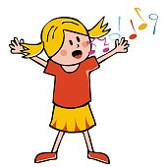-------------------------------------------------------------------

-------------------------------------------------------------------
-------------------------------------------------------------------
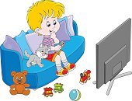-------------------------------------------------------------------
----------------------------------------------------------------------------
2) Doplň podle obrázku, co umíš a co neumíš.
----------------------------------------------------------------------------
 

